**C++**

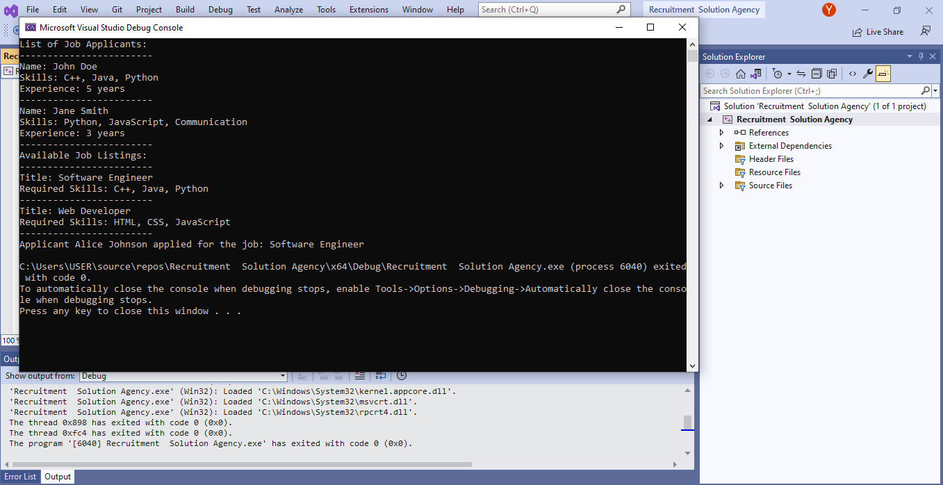**Project: RECRUITMENT SOLUTION AGENCY**